**Simulations**

Before starting hardware implementation, according to selected topology, some simulations were done. These results of simulations were taken from MATLAB Simulink.

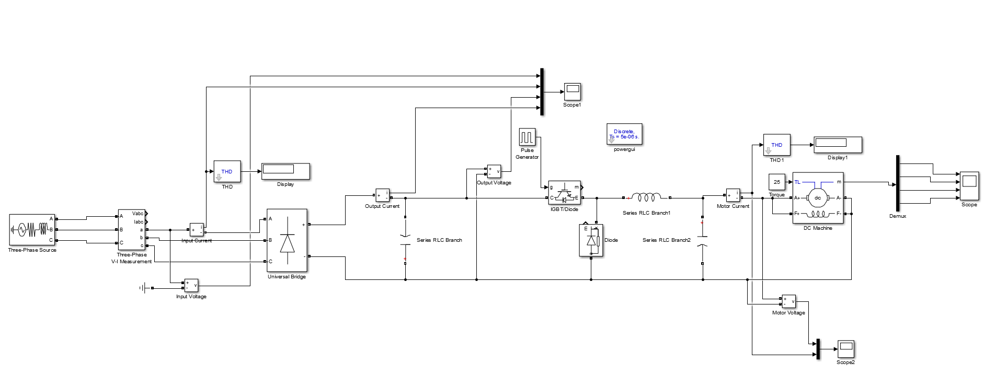

Figure 1: Design Schematic of the Selected Topology

In Figure 1, design schematic of the selected topology is given. Simulation results are taken from the output of the diode rectifier, output of the buck converter and the measurement pin of the DC motor. Also to analyze THD of the input current, input measurement is taken from the source side. Firstly, 85% duty cycle PWM signal is given the switching element and the measurements are observed.

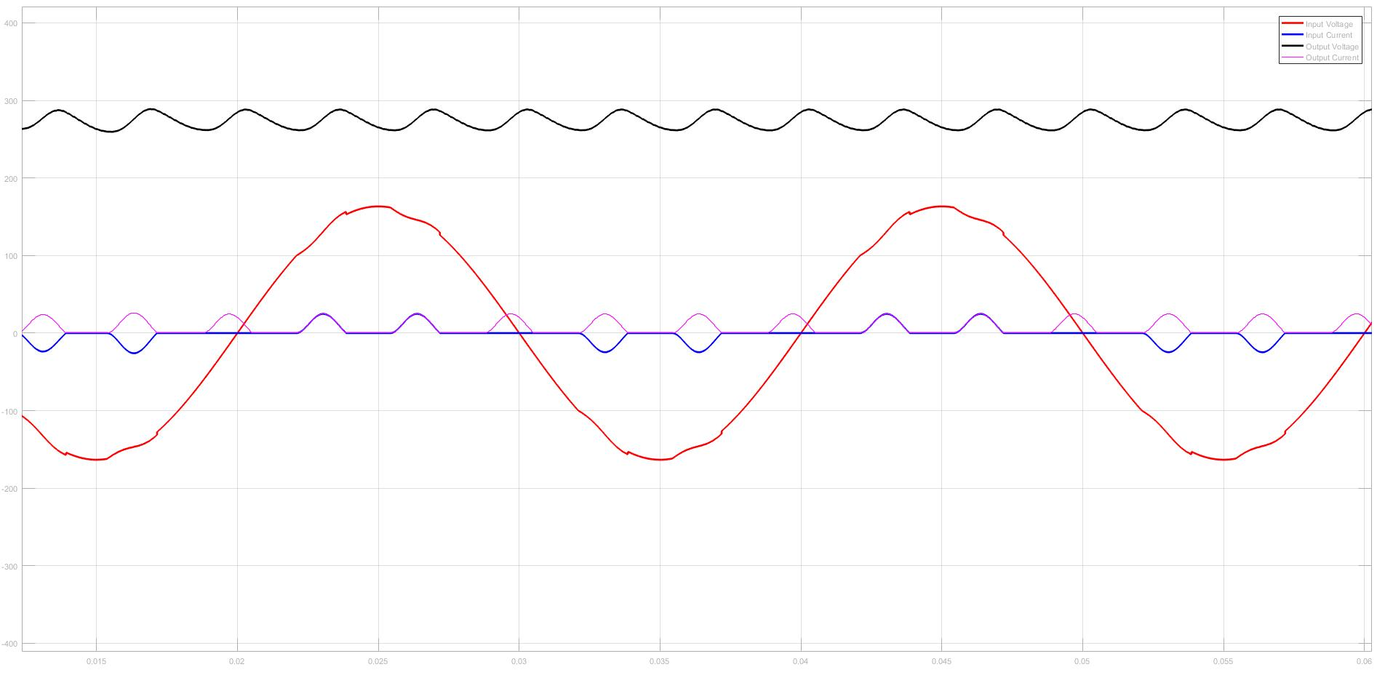

Figure 2: Input and Output Characteristic of the 3-Phase Diode Rectifier (85% Duty Cycle)

THD of the input current is equal to 126%.

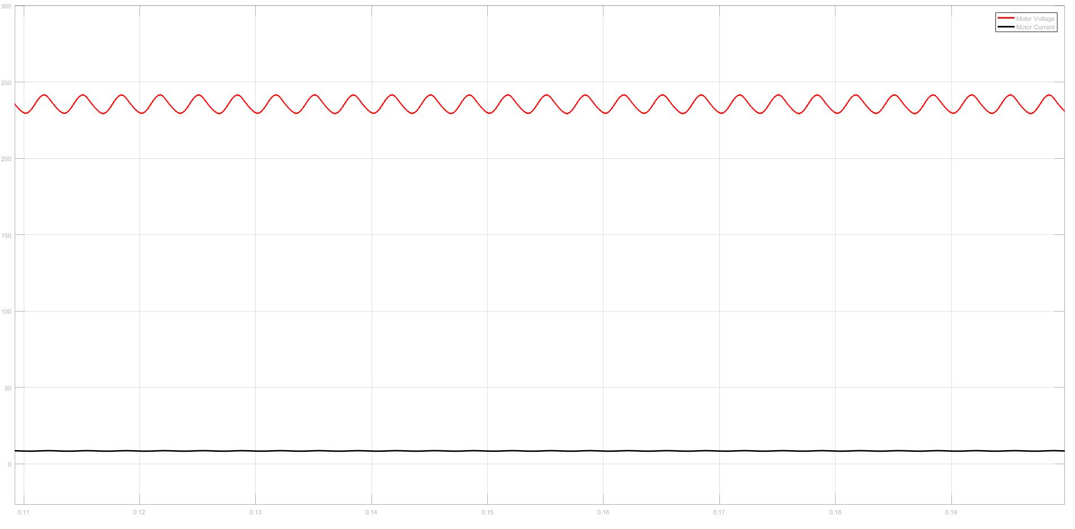

Figure 3: Output Characteristic of the Buck Converter (85% Duty Cycle)

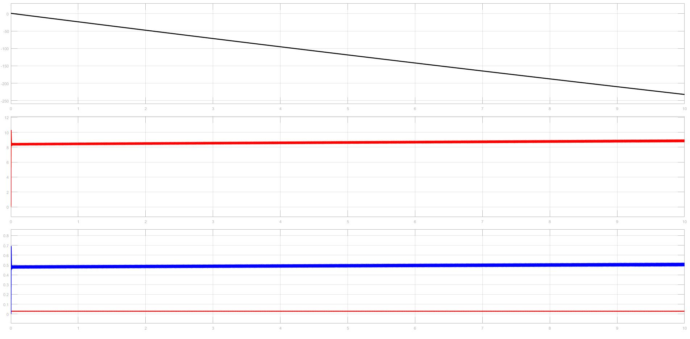

Figure 4: Motor Characteristic of the System (85% Duty Cycle)

Same procedure was applied for the 50% duty cycle and 15% duty cycle cases.

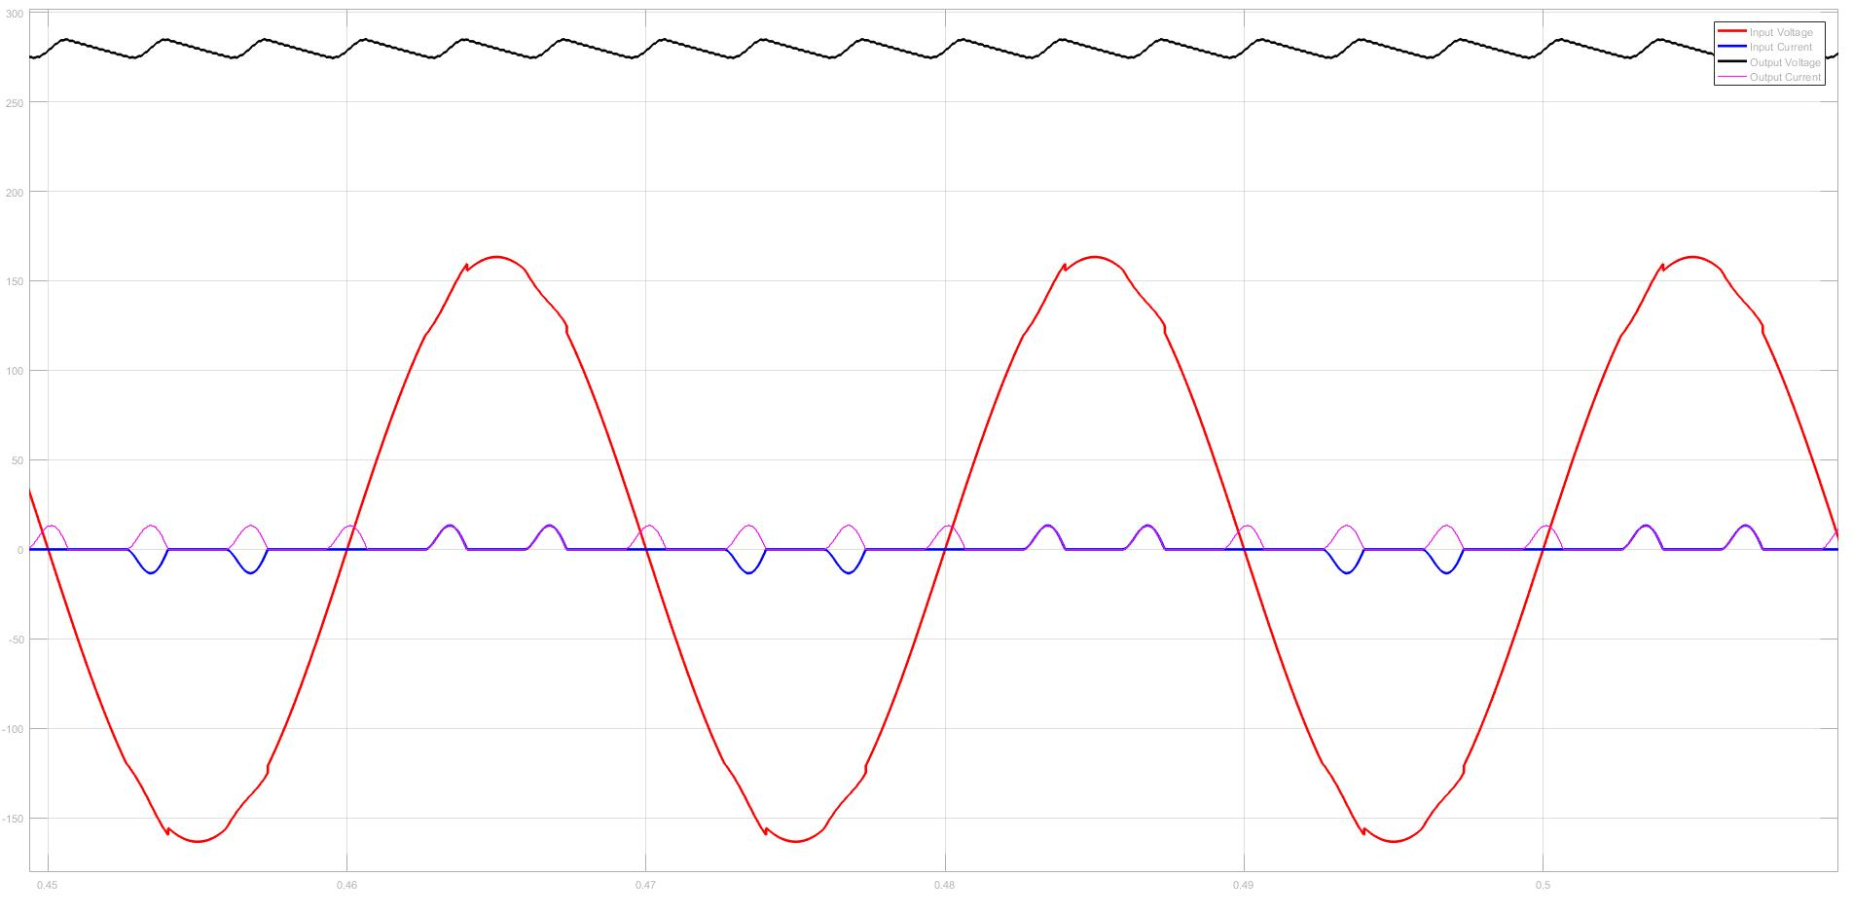

Figure 5: Input and Output Characteristic of the 3-Phase Diode Rectifier (50% Duty Cycle)

THD of the input current is equal to 149%.

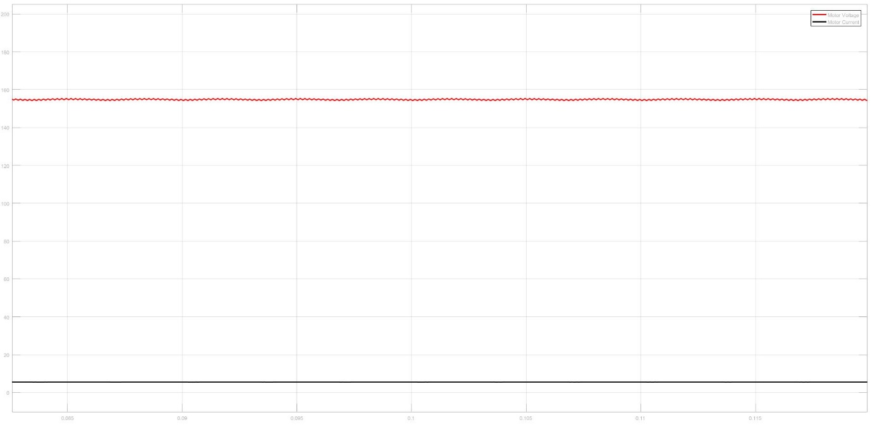

Figure 6: Output Characteristic of the Buck Converter (50% Duty Cycle)

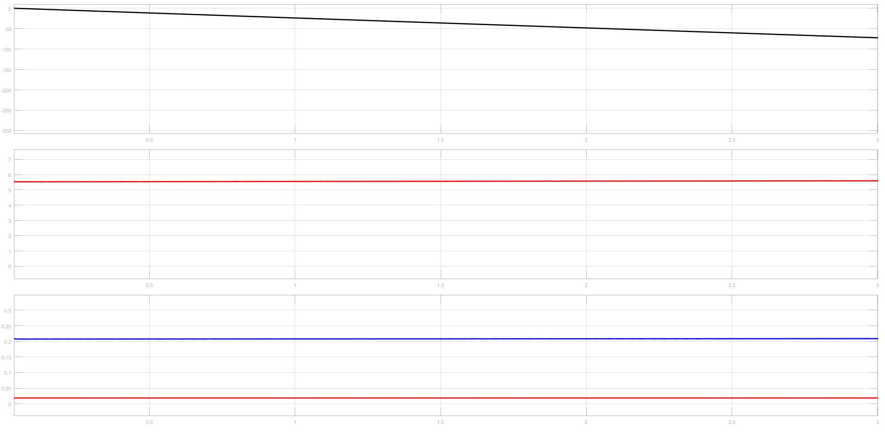

Figure 7: Motor Characteristic of the System (50% Duty Cycle)

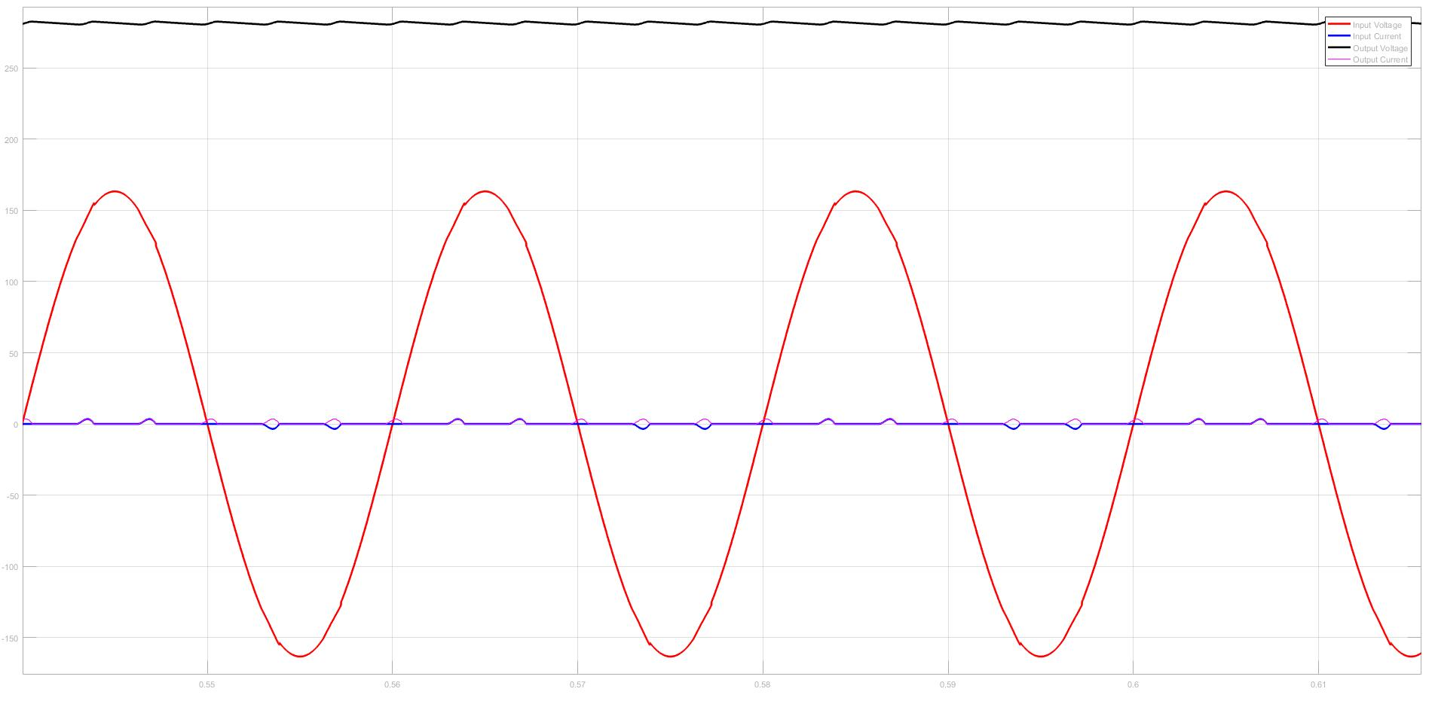

Figure 8: Input and Output Characteristic of the 3-Phase Diode Rectifier (15% Duty Cycle)

THD of the input current is equal to 191%.

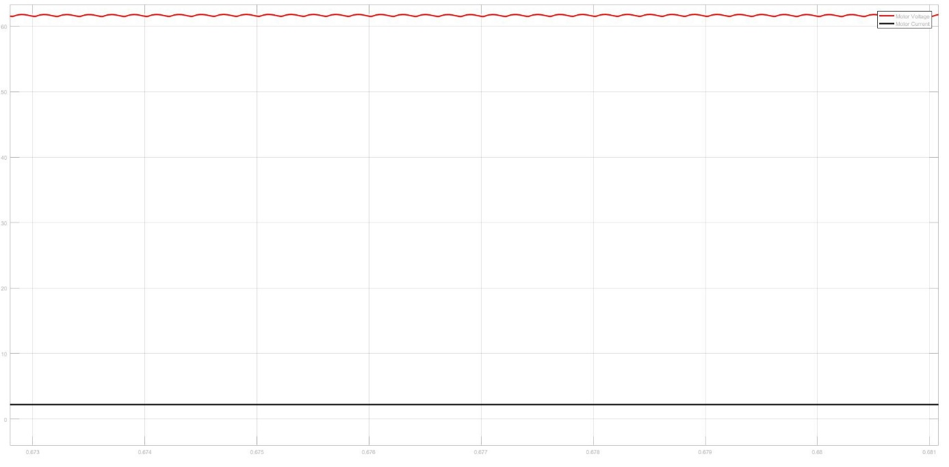

Figure 9: Output Characteristic of the Buck Converter (15% Duty Cycle)

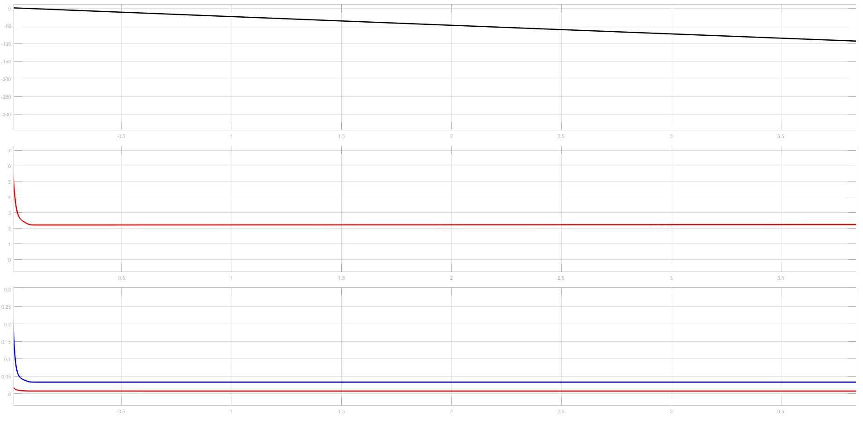

Figure 10: Motor Characteristic of the System (15% Duty Cycle)

According to these simulation results, characteristic of the selected topology was investigated. At the end, we decided that this topology totally suitable with our system. It is easy to use and it is efficient than other topologies. Also, some of the future problems are observed such as high starting current problem. Also PWM generation problem was considered and we decided that Arduino will be used for PWM generation and it will be connected to the system with an optocoupler circuit to isolate it from the driver circuit.

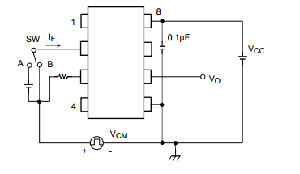

Figure 11: Schematic of the Optocoupler Circuit

**Component Selection**

Component selection is one of the most importing thing for hardware implementation. Since, components should be proper for the system and also their price performance ration should be in acceptable range. Also rating of the components should be selected proper since reliability of the system directly related with the rating of the components.

Firstly, components used in simulations were searched and their prices were listed. Then according to ratings, prices and accessibility one of them was selected.

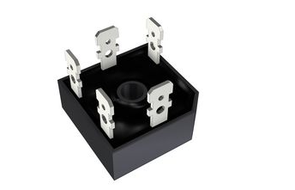

Figure 12: Selected Three-Phase Diode Rectifier (SBR3516)

Figure 12 shows the selected diode rectifier and Table 1 shows the some of the important data of the selected component.

Table 1: Some of the important characteristic of the SBR3516

|  |  |
| --- | --- |
| Peak Repetitive Voltage  Working Peak Reverse Voltage  DC Blocking Voltage | 1600V |
| Peak Non-Repetitive Reverse Voltage | 1700V |
| RMS Reverse Voltage | 1120V |
| Maximum Average Forward  Rectified Current @Tc = 60°C | 35A |
| Operating Temperature Range | -55°C to +150°C |
| Thermal Resistance Junction to Case at  DC Operation per Bridge | 1.16 k/W |
| Thermal Resistance Case to Heatsink Mounting  Surface, Smooth, Flat and Greased | 0.2k/W |

After that, switching element was selected. During this process, we searched two different component types which are IGBT and MOSFET. At the end we decided that MOSFET will be more reliable for our system. And according to similar criteria with component selecting we found a MOSFET which is proper for our system.

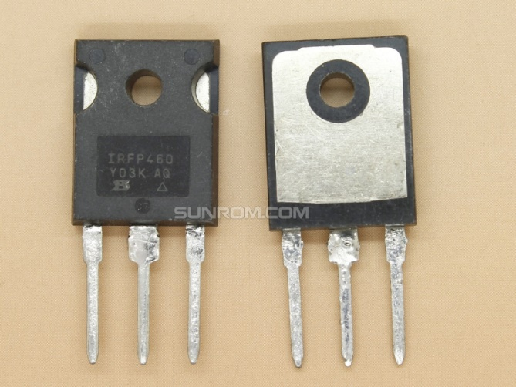

Figure 13: Selected MOSFET (IRFP460)

Figure 13 shows the selected MOSFET and Table 2 shows the important properties of the selected MOSFET.

Table 2: Some of the important properties of the IRFP460

|  |  |
| --- | --- |
| Drain-source voltage | 500V |
| Drain-gate voltage | 500V |
| Gate-source voltage | +-30V |
| Continuous drain current | 20A |
| Pulsed drain current | 80A |
| Total dissipation | 250W |
| Operating junction and storage temperature range | -55°C to 150°C |
| Thermal resistance junction to mounting base | 0.5K/W |
| Thermal resistance junction to ambient | 45K/W |
| Continuous source current (body diode) | 20A |

Then a diode was selected for the Buck Converter.

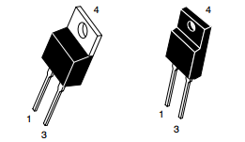

Figure 14: Selected Diode (U1560)

Average rectified forward current of this diode is equal to 15A and peak rectified forward current is equal to 30A.

After that, capacitors are selected for the DC link and low pass filter of the Buck Converter. Value of the capacitors are selected according to simulations and they were determined as 680uF. Then we started to examine proper capacitors for our system.

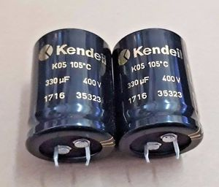

Figure 15: Selected Capacitors (Kendeil 400V 680uF)

Figure 15 shows the selected capacitors for our system.

After that we started to search for our last component which is inductor. Value of the inductor was determined according to simulation results. In the stores, we could not find proper inductor for our system so that we decided to make our inductor with a ferrite core and copper cable.

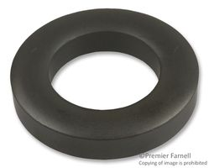

Figure 16: Ferrite core, Toroid 77

According to following equation,

A: cross-sectional area

r: toroid radius to centerline

number of the turns calculated. According to simulations, value of the inductor determined as 1.3mH.

Also, according to thermal design calculations we bought proper heatsinks and a fan for our system.

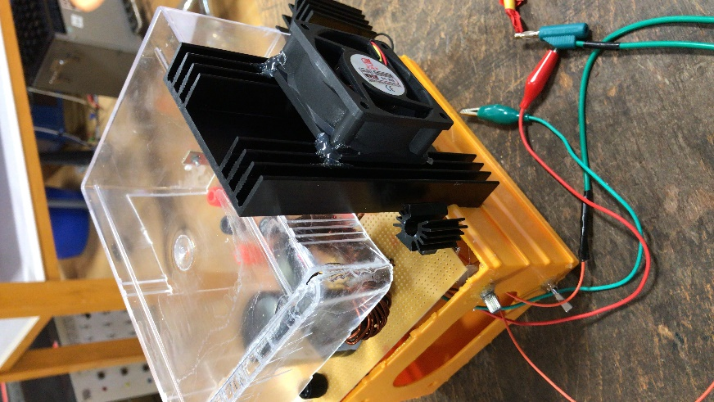

Figure 17: Used Heatsink and Fan